**Software Installation Document**

**List of Software’s to be installed.**

|  |  |
| --- | --- |
| Software name | Version |
| Anaconda | **2020.02** |
| Git | **2.26.0** |
| VS Code | **1.43** |

**Anaconda Installation**

**Installing on Windows**

1. [Download the Anaconda installer](https://www.anaconda.com/download/#windows).
2. RECOMMENDED: [Verify data integrity with SHA-256](https://docs.anaconda.com/anaconda/install/hashes/). For more information on hashes, see [What about cryptographic hash verification?](https://conda.io/projects/conda/en/latest/user-guide/install/download.html#cryptographic-hash-verification)
3. Double click the installer to launch.

**Note**

To prevent permission errors, do not launch the installer from the [Favorites folder](https://docs.anaconda.com/anaconda/user-guide/troubleshooting/" \l "distro-troubleshooting-favorites-folder).

**Note**

If you encounter issues during installation, temporarily disable your anti-virus software during install, then re-enable it after the installation concludes. If you installed for all users, uninstall Anaconda and re-install it for your user only and try again.

1. Click Next.
2. Read the licensing terms and click “I Agree”.
3. Select an install for “Just Me” unless you’re installing for all users (which requires Windows Administrator privileges) and click Next.
4. Select a destination folder to install Anaconda and click the Next button. See [FAQ](https://docs.anaconda.com/anaconda/user-guide/faq/#distribution-faq-windows-folder).

**Note**

Install Anaconda to a directory path that does not contain spaces or unicode characters.

**Note**

Do not install as Administrator unless admin privileges are required.

[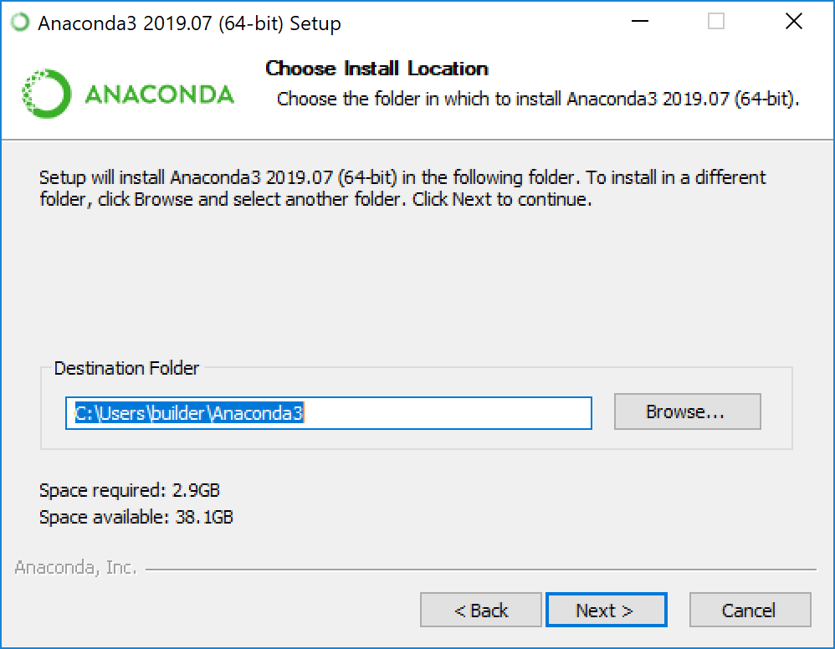](https://docs.anaconda.com/_images/win-install-destination.png)

1. Choose whether to add Anaconda to your PATH environment variable. We recommend not adding Anaconda to the PATH environment variable, since this can interfere with other software. Instead, use Anaconda software by opening Anaconda Navigator or the Anaconda Prompt from the Start Menu.

[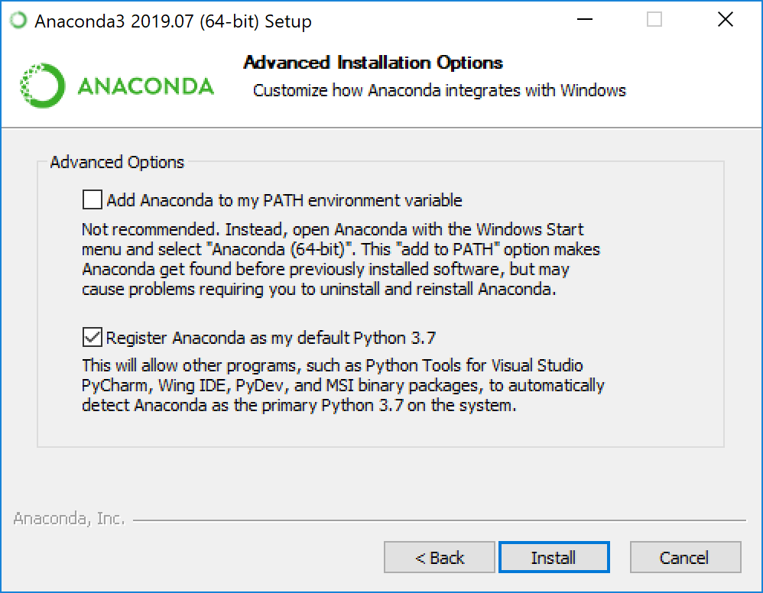](https://docs.anaconda.com/_images/win-install-options.png)

1. Choose whether to register Anaconda as your default Python. Unless you plan on installing and running multiple versions of Anaconda or multiple versions of Python, accept the default and leave this box checked.
2. Click the Install button. If you want to watch the packages Anaconda is installing, click Show Details.
3. Click the Next button.
4. Optional: To install PyCharm for Anaconda, click on the link to <https://www.anaconda.com/pycharm>.

[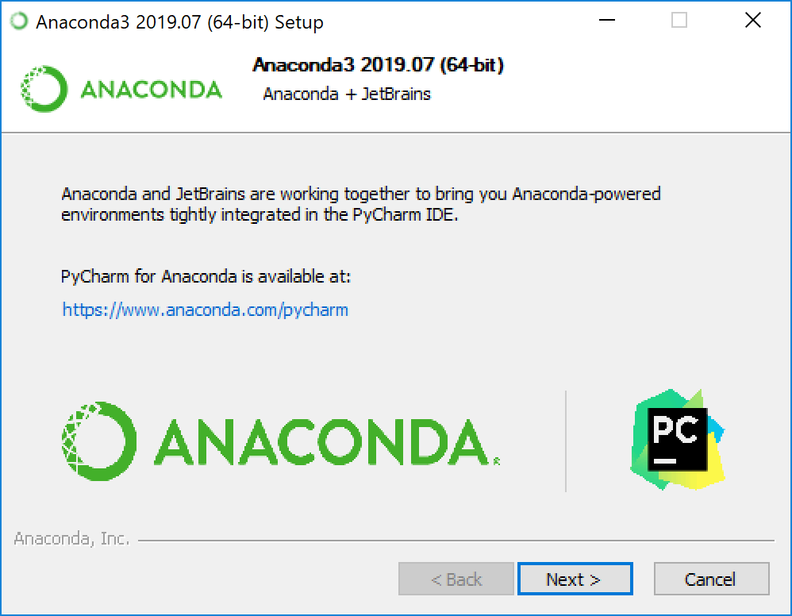](https://docs.anaconda.com/_images/win-install-pycharm.png)

Or to install Anaconda without PyCharm, click the Next button.

1. After a successful installation you will see the “Thanks for installing Anaconda” dialog box:

[](https://docs.anaconda.com/_images/win-install-complete.png)

1. If you wish to read more about Anaconda Cloud and how to get started with Anaconda, check the boxes “Learn more about Anaconda Cloud” and “Learn how to get started with Anaconda”. Click the Finish button.
2. [Verify your installation](https://docs.anaconda.com/anaconda/install/verify-install/).

**Git Installation**

Download the Git from official web site [git-scm.com,](https://git-scm.com/download/win) and download the latest version of Git.

1. Right click on downloaded Git file and run as administrator, then you can see the below information dialogue to go further installation.

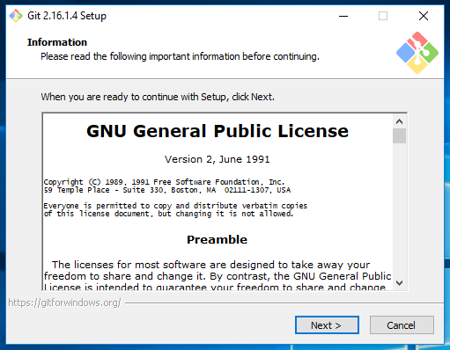

Read General Public Licence and click on Next>.

1. It will ask for Git installation directory by default it will be in ***C:\Program Files\Git***, you can change if you wish.

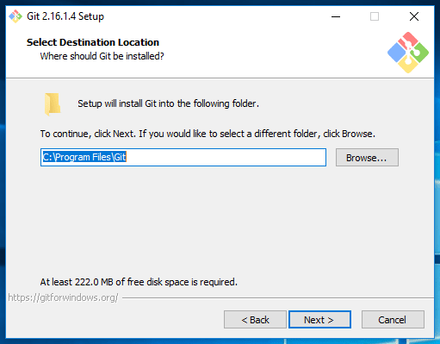

Click on Next>

1. This step allows you to select the git components which you want to install as part of the git installation.

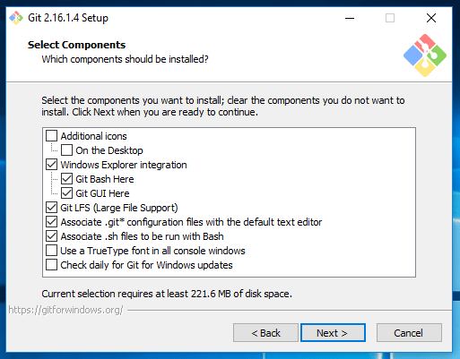

Above selection is recommended, those recommendations bring you Git GUI and Git Command prompt.

Click Next >

1. This dialogue asking you to create shortcuts of git, leave this as default and click Next >

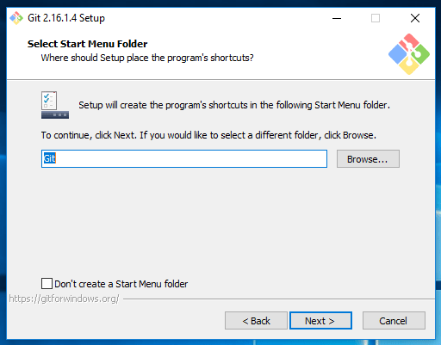

1. Choose your favourite text editor to work with Git.

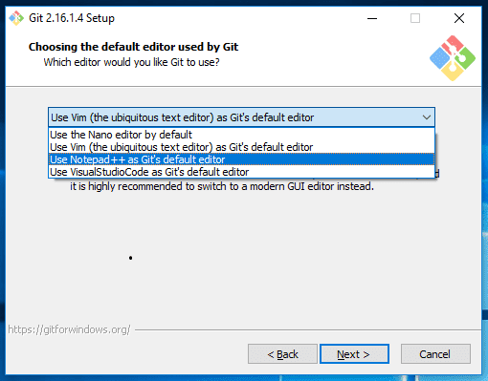

Click on Next >**:**

1. This dialogue asking you to how do you want to use git to set the PATH, go with the recommended option.

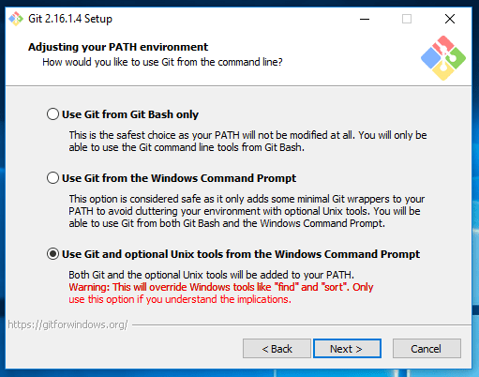

By choosing this step git automatically set PATH for you. I will show you how to see the generated PATH at the end of this article.

Click on Next >

1. Choose for HTTPS transport, leave it as default.

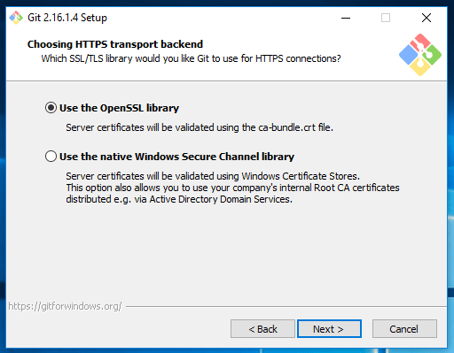

Click on Next >

1. Configuring the line ending conversions, leave it as default recommendation.

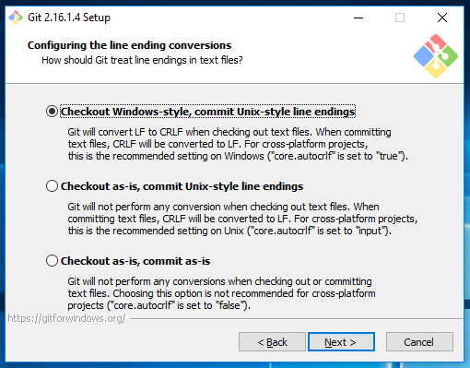

Click on Next>

1. Choose for the terminal emulator to use Git Bash.

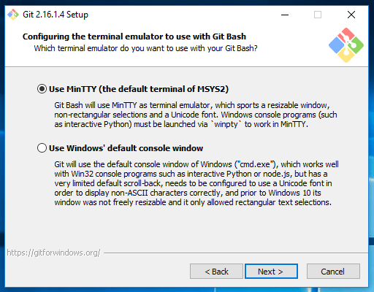

Click on Next >

1. This window allows you to enable extra features. Select the below recommendations.

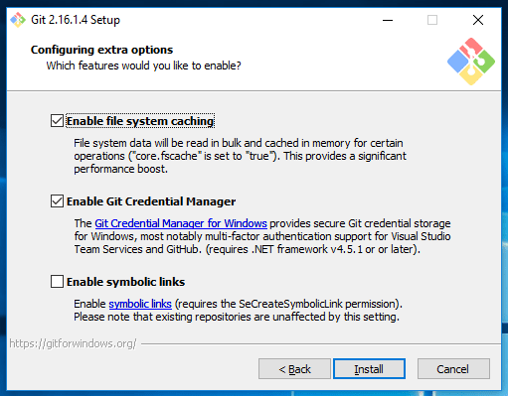

Click on Install

1. Now started the installation process.

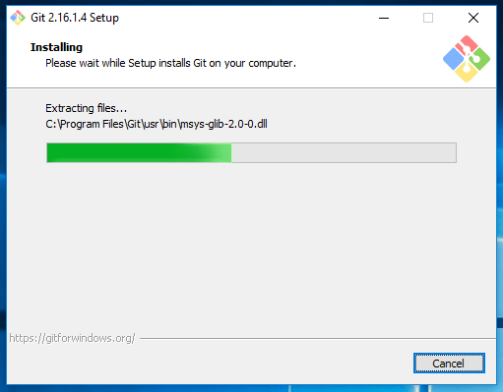

It will take a couple of minutes to complete.

1. If everything is done well, you can see the below information.

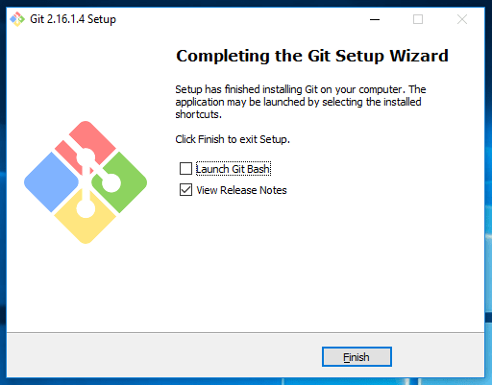

Click on Finish.

Now you can install the Git on Windows 10 operating system.

**Check It :**

Check whether PATH has been set or not.

Advanced System Settings > Environment Variables > System Variables > select Path and click on Edit. You can see the below git paths.

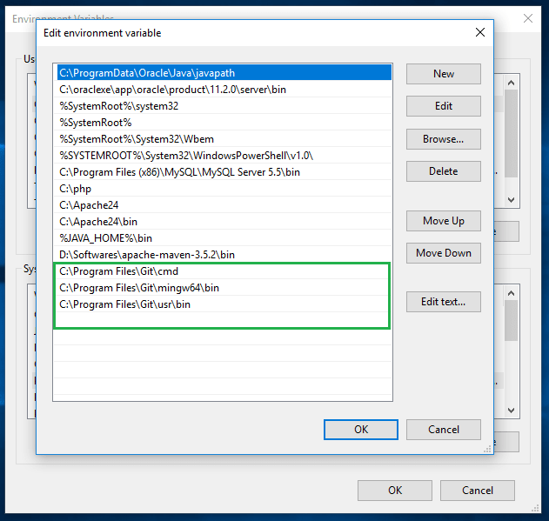

**Run it :**

Open command prompt and type git –version, you should see your installed git version like below.

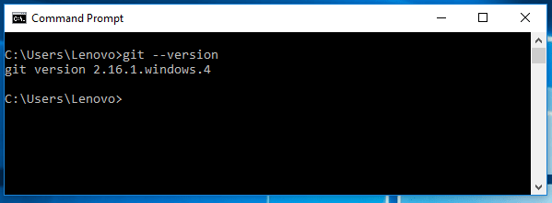

Now you can confirm that git has been installed successfully on your machine.

**VS Code Installation**

1. Download the [Visual Studio Code installer](https://go.microsoft.com/fwlink/?LinkID=534107) for Windows.
2. Once it is downloaded, run the installer (VSCodeUserSetup-{version}.exe). This will only take a minute.
3. By default, VS Code is installed under C:\users\{username}\AppData\Local\Programs\Microsoft VS Code.